|  |
| --- |
| **Electrical Network Analysis** |
| **EL-228** |
| **LABORATORY MANUAL** |
| **Fall 2018** |



|  |  |  |  |  |  |  |
| --- | --- | --- | --- | --- | --- | --- |
| **LAB 09** | | | | | | |
| **DC Voltmeter and Ammeter using Arduino** | | | | | | |
| **Engr. Khalid Usman** | | | | | | |
| ________________________________________ | | __________ | | ___ _______ | | |
| ________________________________________ | | __________ | | ___ | | _______ |
| STUDENT NAME | | ROLL NO | | SEC | | DATE |
|  | | | | | | |
| ______________________________________ | | | | | | |
| LAB ENGINEER SIGNATURE & DATE | | | | | | |
| **MARKS AWARDED:**  /**10** | | | | | | |
| ___________________________________________________________________________ | | | | | | |
| **NATIONAL UNIVERSITY OF COMPUTER AND EMERGING SCIENCES (NUCES), ISLAMABAD** | | | | | | |
|  | | | | | | |
| Prepared by: | Engr. Aamer Munir | | Version: | | 1.0 | |
| Last Edited by: | Engr. Khalid Usman | | Date: | | 29 October, 2018 | |
| Verified by: | Engr. Aamer Munir | | Date: | | 30 October, 2018 | |
|  |  | |  | |  | |

|  |  |  |
| --- | --- | --- |
| **LAB:** | **09** | **DC Voltmeter and Ammeter using Arduino.** |

#### **Learning Objectives:**

In this lab session you will learn how to:

1. Interface LCD Module with Arduino (output).
2. Display text string on LCD
3. Read analog input (input)
4. Measure DC volatge using Arduino
5. Design and implement a current to voltage converter
6. Measure DC current usnig Arduino

**Tools needed:**

1. PC running Windows Operating System (OS)
2. Arduino IDE (installed)
3. Arduino Kit
4. LCD Module
5. Potentiometer (5KΩ or 10KΩ)
6. Resistor of 220Ω
7. Breadboard
8. Jumper wires
9. Operational amplifier IC (741)

Turn on the PC, connect and configure the Arduino provided to you. Run test examples provided within Arduino IDE to verify if it is properly connected or not.

**Note:**

The information and concepts discussed in this lab manual are in sufficient detail but are still not exhaustive. It is assumed that all these concepts are already taught to you in your ITC theory class.

1. **Interface LCD Module with Arduino**

**Liquid Crystal Display (LCD)**

A **Liquid Crystal Display** commonly abbreviated as **LCD** is basically a display unit built using [*Liquid Crystal technology*](http://www.circuitstoday.com/liquid-crystal-displays-lcd-working). When we build real life/real world electronics based projects, we need a medium/device to display output values and messages. The most basic form of electronic display available is [7 Segment display](http://www.circuitstoday.com/arduino-and-7-segment-display) – which has its own limitations. The next best available option is [Liquid Crystal Displays](http://www.circuitstoday.com/a-note-on-character-lcd-displays)which comes in different size specifications. Out of all available LCD modules in market, the most commonly used one is **16x2 LCD Module** which can display 32 ASCII characters in 2 rows (16 characters in 1 row).

#### **16x2 LCD Module Pin Out Diagram**

The LCD module has 16 pins and can be operated in 4-bit mode or 8-bit mode. Here we are using the LCD module in 4-bit mode. Before going in to the details of the project, let’s have a look at the JHD162A LCD module. The pin layout of a JHD162A LCD pin diagram is given below:

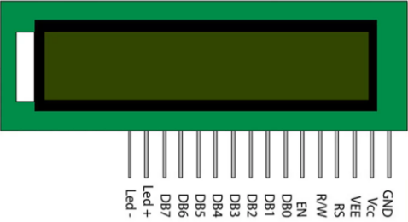

The name and function of each pin of the 16×2 LCD module is given below.

|  |  |  |
| --- | --- | --- |
| **Pin#** | **Name** | **Purpose** |
| **1** | **GND or VSS** | Ground pin of the LCD module. |
| **2** | **VCC or VDD** | Power to LCD module (+5V supply is given to this pin) |
| **3** | **VEE or Vo** | Contrast adjustment pin. This is done by connecting the ends of a 10K potentiometer to +5V and ground and then connecting the slider pin to the VEE pin. The voltage at the VEE pin defines the contrast. The normal setting is between 0.4 and 0.9V. |
| **4** | **RS** | Register select pin. The JHD162A has two registers namely **command register** and **data register**. Logic HIGH at RS pin selects data register and logic LOW at RS pin selects command register. If we make the RS pin HIGH and feed an input to the data lines (DB0 to DB7), this input will be treated as data to display on LCD screen. If we make the RS pin LOW and feed an input to the data lines, then this will be treated as a command ( a command to be written to LCD controller – like positioning cursor or clear screen or scroll). |
| **5** | **R/W** | Read/Write modes. This pin is used for selecting between read and write modes. Logic HIGH at this pin activates read mode and logic LOW at this pin activates write mode. |
| **6** | **E or EN** | This pin is meant for enabling the LCD module. A HIGH to LOW signal at this pin will enable the module. |
| **7-14** | **DB0 to DB7** | These are data pins. The commands and data are fed to the LCD module though these pins. |
| **15** | **Led+** | Anode of the back light LED. When operated on 5V, a 560 ohm resistor should be connected in series to this pin. In Arduino based projects the back light LED can be powered from the 3.3V source on the Arduino board. |
| **16** | **Led-** | Cathode of the back light LED. |

**Interfacing LCD Module with Arduino**

Interface the LCD Module with Arduino based on the following schematic and layout diagrams using jumper wires, a resistor and a potentiometer.

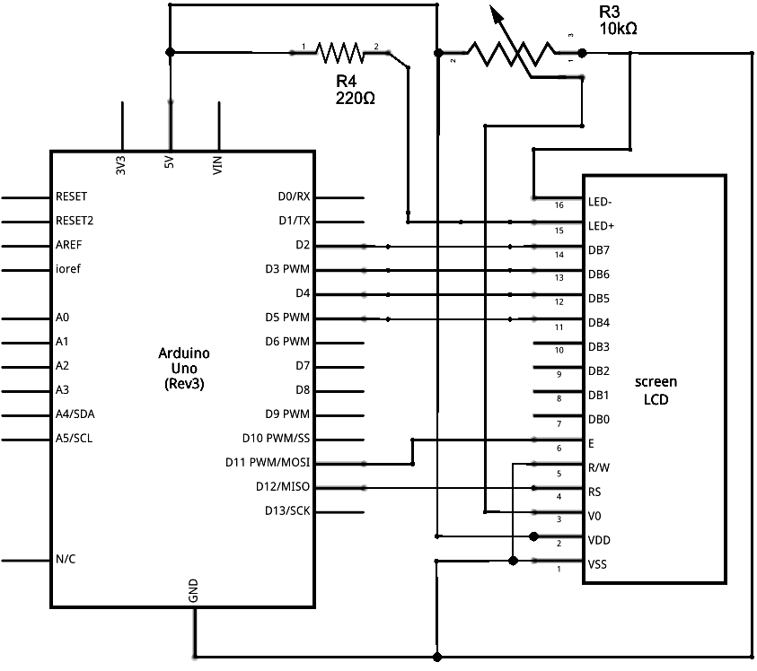

**Schematic diagram of LCD module connected with Arduino UNO**

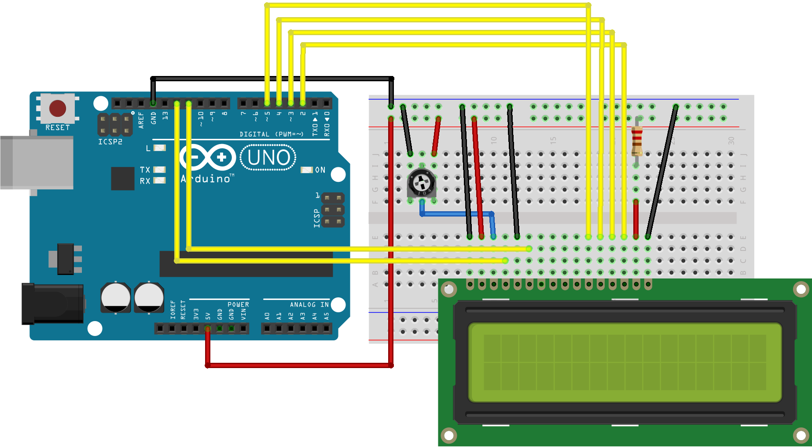

**Layout diagram of LCD module connected with Arduino UNO.**

Connections to be made are listed in a table below:

|  |  |  |
| --- | --- | --- |
| **S#** | **LCD Pin Name** | **Arduino Pin** |
| 1 | Vss | GND |
| 2 | Vdd | 5V |
| 3 | Vo | Middle leg of potentiometer |
| 4 | Rs | 12 |
| 5 | R/W | GND |
| 6 | E or EN | 11 |
| 7 | D4 | 5 |
| 8 | D5 | 4 |
| 9 | D6 | 3 |
| 10 | D7 | 2 |
| 11 | LED+ | 5V through 220Ω resistor. |
| 12 | LED- | GND |

1. **Display text string on LCD:**

Conventionally, the first code to test an output device that can show text is to display the string "Hello World!" on to it.

***Sample code 1: "Hello, World!"***

#include <LiquidCrystal.h>

// init the library by associating any needed LCD interface pin

// with the arduino pin number it is connected to

const int rs = 12, en = 11, d4 = 5, d5 = 4, d6 = 3, d7 = 2;

LiquidCrystal lcd(rs, en, d4, d5, d6, d7);

void setup()

{

// set up the LCD's number of columns and rows:

lcd.begin(16, 2);

// Print a message to the LCD.

lcd.print("Hello, World!");

}

void loop()

{

}

***Sample code 2: Blinking "Hello, World!"***

#include <LiquidCrystal.h>

// init the library by associating any needed LCD interface pin

// with the arduino pin number it is connected to

const int rs = 12, en = 11, d4 = 5, d5 = 4, d6 = 3, d7 = 2;

LiquidCrystal lcd(rs, en, d4, d5, d6, d7);

void setup()

{

// set up the LCD's number of columns and rows:

lcd.begin(16, 2);

// Print a message to the LCD.

lcd.print("Hello, World!");

}

void loop()

{

// Turn off the display:

lcd.noDisplay();

delay(500);

// Turn on the display:

lcd.display();

delay(1000);

}

1. **Reading analog inputs:**

It's relatively simple to use an Arduino to measure voltages. The Arduino has several analog input pins that connect to an analog-to-digital converter (ADC) inside the Arduino. The Arduino ADC is a 10-bit converter, meaning that the output value will range from 0 to 1023. We will obtain this value by using the *analogRead()* function. If you know the reference voltage -- in this case we will use 5V -- you can easily calculate the voltage present at the analog input (this is known as calibration).

In this experiment, we will make digital voltmeter capable of measuring up to 5V using an Arduino board and a 16x2 LCD.

Use a jumper wire connected to Arduino pin A0 to connect to the point whose voltage is to be measured with respect to the GND.

**Digital Voltmeter Sample Code:**

Following is the code for the DVM.

#include "LiquidCrystal.h"

const int rs = 12, en = 11, d4 = 5, d5 = 4, d6 = 3, d7 = 2;

LiquidCrystal lcd(rs, en, d4, d5, d6, d7);

float input_voltage = 0.0;

float temp=0.0;

void setup()

{

Serial.begin(9600); //opens serial port, sets data rate to 9600 bps

lcd.begin(16, 2); //set up the LCD's number of columns and rows:

lcd.print("DVM by i170999");

}

void loop()

{

//Conversion formula for voltage

int analog_value = analogRead(A0);

input_voltage = (analog_value * 5.0) / 1024.0;

if (input_voltage < 0.1)

{

input_voltage = 0.0;

}

Serial.print("v = ");

Serial.println(input_voltage);

lcd.setCursor(0, 1);

lcd.print("Voltage = ");

lcd.print(input_voltage);

delay(300);

}

**Note:**

The lines of code that begin with 'Serial.' aren't needed for interfacing with LCD. Instead they are to print out the output on the Serial Monitor. It is a good tool for debugging to see whether the code is working fine or not. If the LCD is not showing anything but the Serial Monitor is, may mean the connections with the LCD module are faulty and/or the LCD module itself is faulty.

You need to understand the interfacing of both LCD and analog input. This knowledge/skill would be essential for you to be able to complete your ENA Lab Project.

**Lab Task # 1:**

Modify the above code for above DVM so that it can measure the DC voltage from 0-20V.

**DC Ammeter:**

A current to voltage converter will produce a voltage proportional to the given current. This circuit is required as Arduino is capable only of measuring voltages and we need to measure the current output.

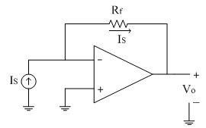

**Schematic diagram of Current to Voltage Converter**

We can find the output voltage of the above circuit by using the following formula:

$$V_{O}=I_{S}R_{f}$$

**Task # 2:**

Make a DC ammeter using Arduino, which has ability to measure current from 0mA-20mA.

**Space for calculation Current to Volatge Converter:**

**Past your modified code for Ammeter in the space given below:**

***Disclaimer:***

*This lab manual is based on the information taken from the following websites:*

1. *http://www.circuitstoday.com/interfacing-lcd-to-arduino*
2. *https://www.arduino.cc/en/Tutorial/HelloWorld*
3. [*https://www.allaboutcircuits.com/projects/make-a-digital-voltmeter-using-the-arduino/*](https://www.allaboutcircuits.com/projects/make-a-digital-voltmeter-using-the-arduino/)
4. *https://www.electronics-tutorial.net/analog-integrated-circuits/current-to-voltage-converter/index.html*

**Important Note:**

The marks for this lab will be awarded based on the way you work during the lab -- the way you build your circuit, troubleshoot in case something is not working and do anything the instructor tells you to do.